**ASSIGNMENT:2 DATE: 26/12/2023**

**Program:1**

**Aim:write to design following patterns.**

**Program(a):**

**#include <stdio.h>**

**int main()**

**{**

**int i, j;**

**for (i = 0; i < 5; i++) {**

**for (j = 0; j <= i; j++) {**

**printf(" *");**

**}**

**printf("\n");**

**}**

**return 0;**

**}**

**Output:**

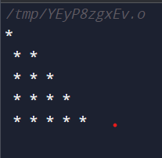

**Program(B):**

**#include <stdio.h>**

**int main()**

**{**

**int i, j, rows;**

**printf("Enter number of rows: ");**

**scanf("%d", &rows);**

**for(i=1; i<=rows; i++)**

**{**

**for(j=i; j<rows; j++)**

**{**

**printf(" ");**

**}**

**for(j=1; j<=i; j++)**

**{**

**printf("*");**

**}**

**printf("\n");**

**}**

**return 0;**

**}**

**Output:**

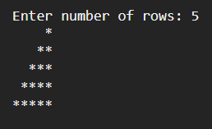

**Program(c ):**

**#include <stdio.h>**

**int main()**

**{**

**int i, j, rows;**

**printf("Enter number of rows : ");**

**scanf("%d", &rows);**

**for(i=1; i<=rows; i++)**

**{**

**for(j=i; j<rows; j++)**

**{**

**printf(" ");**

**}**

**for(j=1; j<=(2*i-1); j++)**

**{**

**printf("*");**

**}**

**printf("\n");**

**}**

**return 0;**

**}**

**Output:**

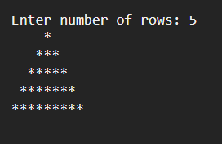

**Program:2**

**Aim:write a program to design a menu containing six options.Each option should have a case and the sixth option is for exiting the program.**

**Program:**

**#include <stdio.h>**

**int main ()**

**{ int weeks;**

**printf("Enter the day (1-7)");**

**scanf("%d",&weeks);**

**switch(weeks) {**

**case 1:**

**printf("sunday");**

**break;**

**case 2:**

**printf("monday");**

**break;**

**case 3:**

**printf("tuesday");**

**break;**

**case 4:**

**printf("wednesday");**

**break;**

**case 5:**

**printf("thursday");**

**break;**

**case 6:**

**printf("friday");**

**break;**

**case 7:**

**printf("saturday");**

**break;**

**case 8: printf("invalid number");**

**break;**

**}**

**}**

**Output:**

